Online Shopping System: FootFusion

Use-Case-Realization Specification: Delete Products

Version <1.0>

Revision History
Date | Version | Description | Author
23/11/2024 | 1.0 | Final Draft | Dao Ngoc Quang

Table of Contents
1. Introduction 4
1.1 Purpose 4
1.2 Scope 4
1.3 Definitions, Acronyms, and Abbreviations 4
1.4 References 4
1.5 Overview 4
2. Flow of Events—Design 5
3. Derived Requirements 6

Use-Case-Realization Specification: Delete Products

Introduction

Purpose

This document outlines the realization of the "Delete Products" use case within the design model, focusing on the collaboration of objects involved in the process.

Scope

This document is specific to the FootFusion website.

Definitions, Acronyms, and Abbreviations
Buyer: An individual using the FootFusion platform to purchase products.

References
Use Case Specification – Delete Products

Overview

This document provides a detailed realization of the "Delete Products" use case for FootFusion. It begins with a textual explanation of the use case, followed by a sequence diagram demonstrating how objects collaborate to achieve the use case. A class diagram illustrates relationships between participating entities. Finally, the document analyzes additional requirements, including non-functional requirements, that need to be addressed during implementation but are not explicitly covered in the design model.

Flow of Events—Design

The buyer can fully delete one or more products from the system, ensuring they are removed from the product list and database.

Sequence diagram
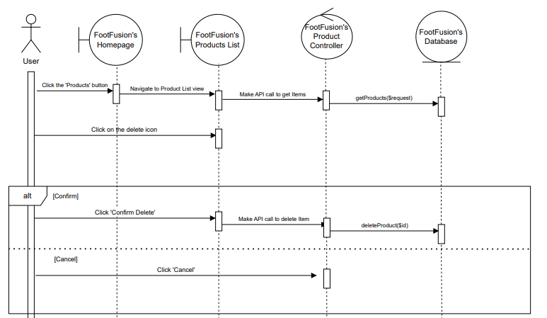

Class diagram
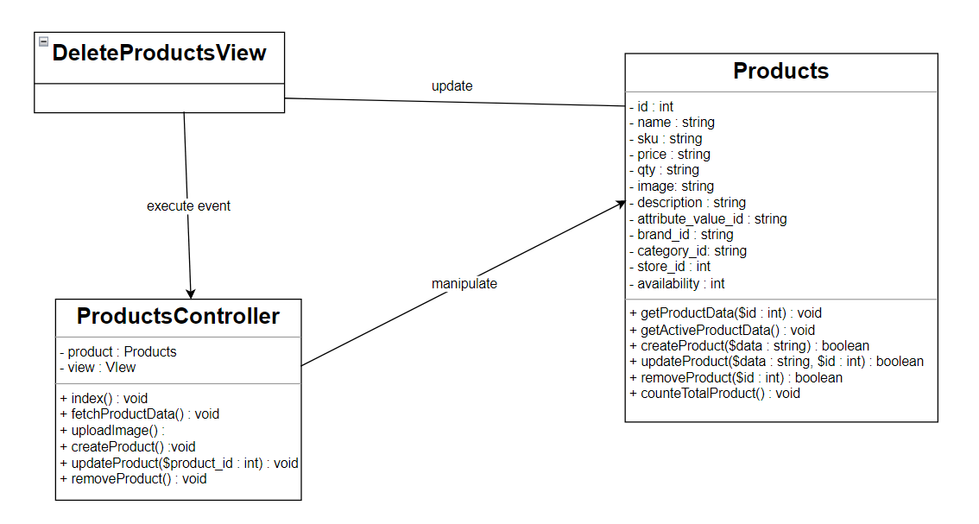

Derived Requirements
There is no derived requirement.

